**Kenneth Posley**

Southern New Hampshire University

[CS-499-H6771 Computer Science Capstone 22EW6](https://learn.snhu.edu/d2l/home/1118298)

**4-2 Milestone Three: Enhancement Two: Algorithms and Data Structures**

1. **Briefly describe the artifact. What is it? When was it created?**

The Artifact that I’ve chosen to enhance is a Hash Table Algorithm from my Data Structures and Algorithms class CS-260, which took place a little more than two years ago. The Hash table is a data structure that stores information in an associative manner. This means that it is stored in an array, which gives each data value its unique index value, allowing for easy access.

1. **Justify the inclusion of the artifact in your ePortfolios. Why did you select this item? What specific components of the artifact showcase your skills and abilities in algorithms and data structure? How was the artifact improved?**

I selected this artifact and have chosen to include it in my ePortfolios because of this assignment’s alignment with the many elements that were introduced in Data Structures and Algorithms CS-260. These elements include but are not limited to advanced algorithmic design, evaluation of complex data structures, and development methodologies. Before I started development, I gave the hash table a good once over to refamiliarize myself with the code flow and researched different data structures and how they work. After, I began rewriting the hash table into the python language. My skill is showcased with this data structure because, although originally written in C++, many code changes were riddled with errors when writing in python.

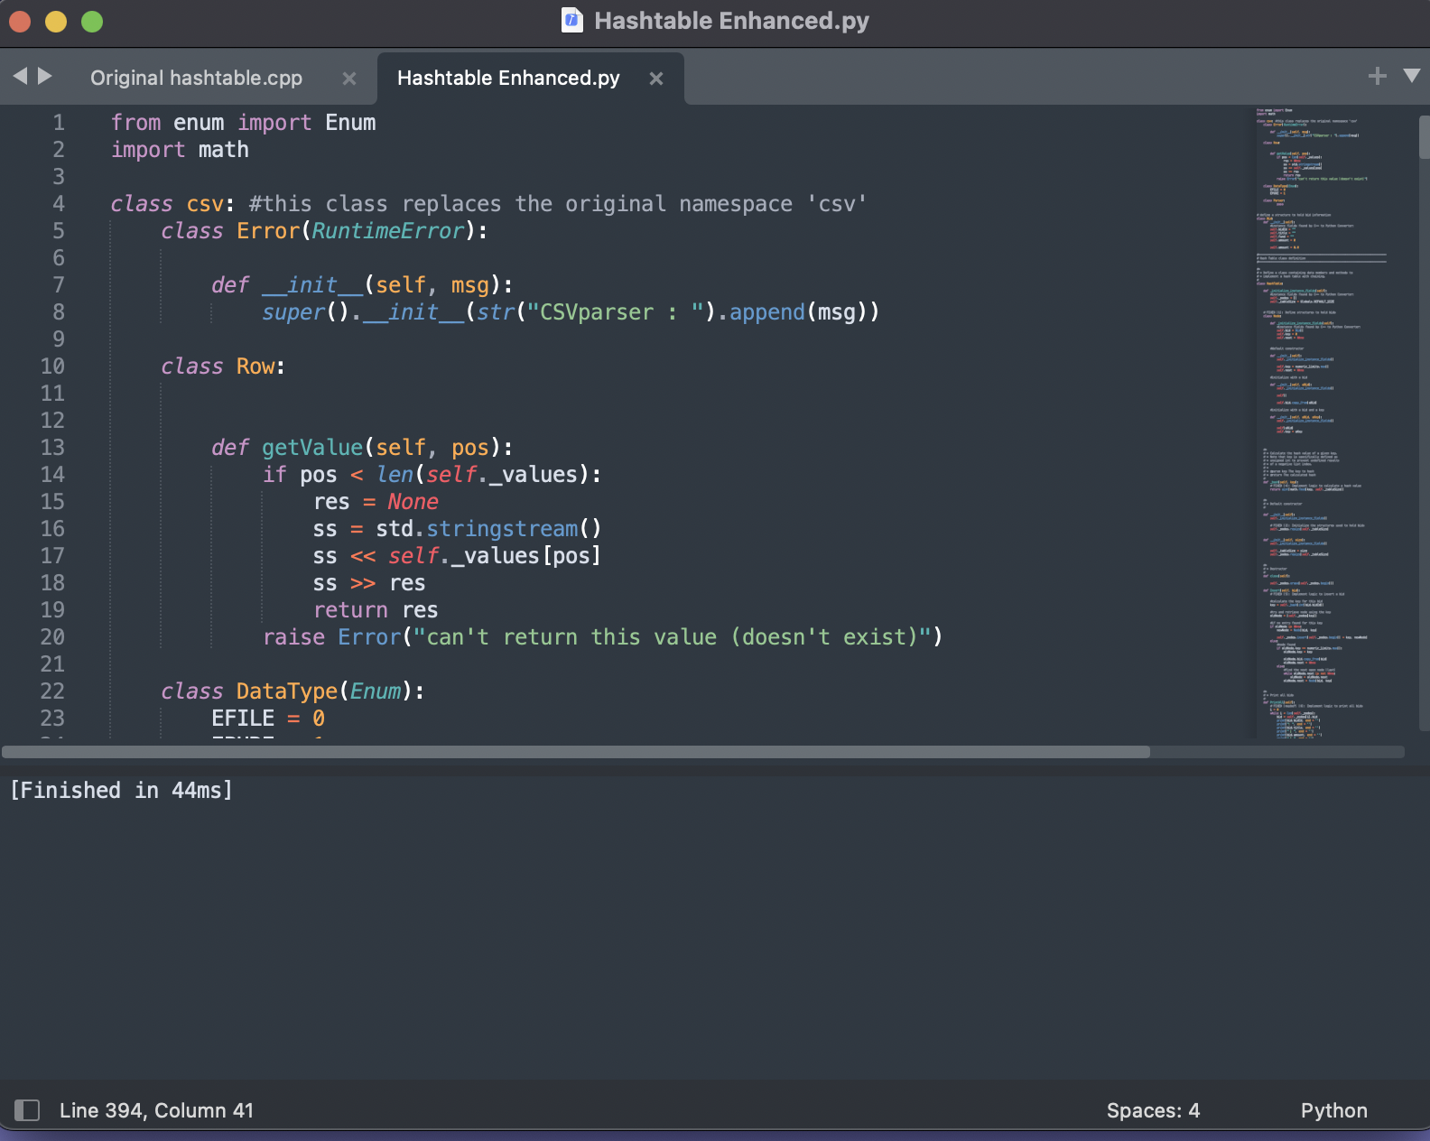

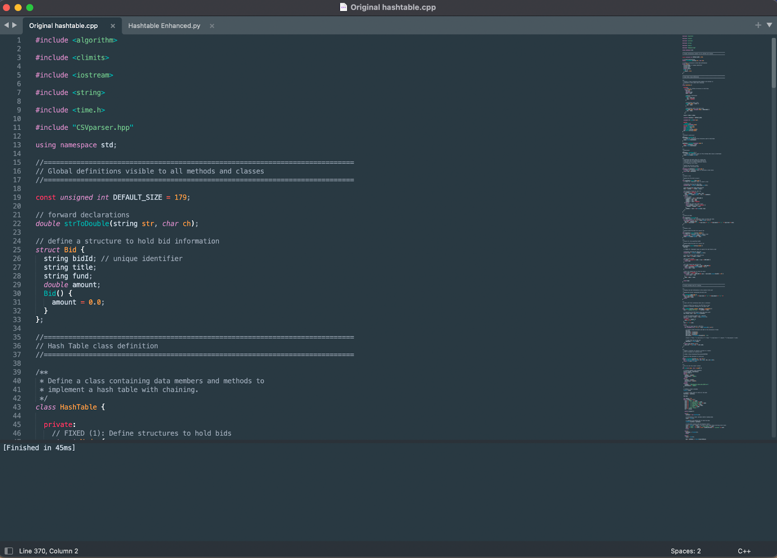

1. **Did you meet the course objectives you planned to meet with this enhancement in Module One? Do you have any updates on your outcome-coverage plans?**

Yes, I do think that I have met the course objectives specifically CS-449-03, and CS-499-04. Throughout this enhancement I’ve had to utilities development best practices such creating pseudocode for some portions of the enhancement to better understand the logic being used. Other techniques regarding testing are using a method in which I only debugged small portion of the code checking for syntax and design errors accordingly. I would like to update my coverage plan to and an element of testing and debugging as there was a very unfortunate number of errors to sift through to deliver a viable result.

1. **Reflect on the process of enhancing and modifying the artifact. What did you learn as you were creating and improving it? What challenges did you face?**

When reflecting on my enhancement of the Hash table data structure artifact from my CS-260 course, I’ve learned and refamiliarized myself many of the data structure and algorithm foundational concept that were learn so long ago. Modifying this artifact has also taught me the importance of logic and design, there were many moments spent just trying the visualize and wrap my mind around the code structure and how it would transition from one language to another. But all in all, the challenges I face were with syntax and debugging, those were the two elements that caused the most difficulties.